11.1.2] Sum of Digits using recursion
ALGORITHM
Step 1: Start the program
Step 2: Define a function sum_of_digits_recursive(n)
Step 3: Check the base condition
→ If n == 0, return 0
Step 4: Otherwise (recursive case)
Step 4.1: Find last digit
→ digit = n % 10
Step 4.2: Call the function again with remaining number
→ sum_of_digits_recursive(n // 10)
Step 4.3: Add digit to recursive result
→ return digit + sum_of_digits_recursive(n // 10)
Step 5: Take input number from user
Step 6: Call the recursive function and store result
Step 7: Print the result
Step 8: End the program
PYTHON CODE
def sum_of_digits_recursive(n):
if n==0:
return 0
else:
return (n%10) + sum_of_digits_recursive( n//10 )
number=int(input())

result = sum_of_digits_recursive(number)
print(result)
FLOWCHART
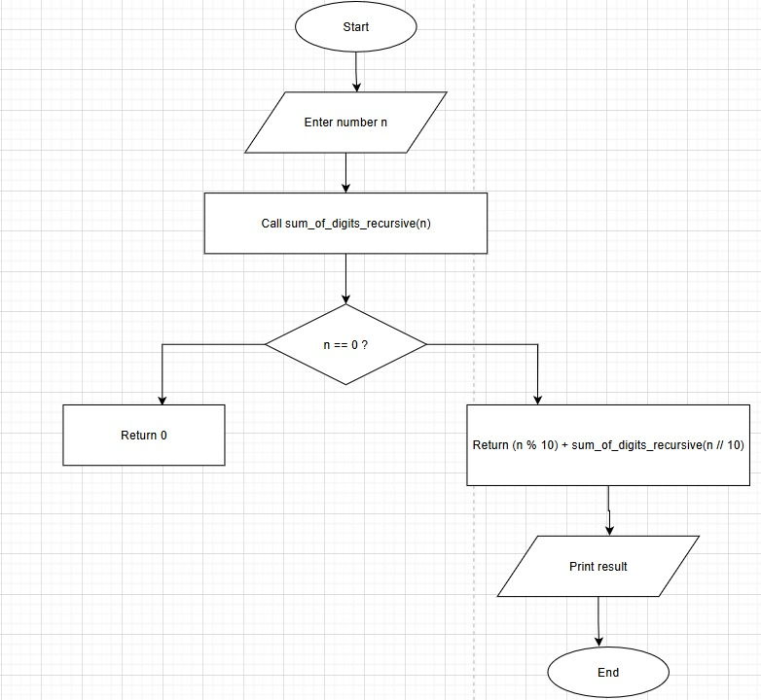
EXCECUTION
